**Project Report**

**on**

**FOOD TRACKING SYSTEM USING**

**BLOCKCHAIN TECHNOLOGY**

|  |  |
| --- | --- |
| **DATE** | **4 NOVEMBER 2023** |
| **TEAM MEMBERS WITH NM ID AND ROLL NUMBER** | 1. **KESHINI S 7F799DCDB03830FB6B649D5D1B6B38DD**   **2020310011**   1. **LIVITHKUMAR M**   **1C12000D84CA76FA3B943E54D2960A45**  **2020310013**   1. **MEGHA MITHRA S**   **3A8DBE8A2268362A4814B7CA5B1E090D**  **2020310014**   1. **NANDHINI DEVI J**   **8FED1EE343D91C3B44C41F8A41F31A18**  **2020310015**   1. **USHA MAYURI G**   **9AA4F57207CE468927C46215591923BC**  **2020310021** |
| **PROJECT NAME** | **FOOD TRACKING SYSTEM USING BLOCKCHAIN TECHNOLOGY** |
| **COLLEGE NAME** | **ALAGAPPA COLLEGE OF TECHNOLOGY, ANNA UNIVERSITY** |

Table of Contents

TABLE OF FIGURES 3

1. INTRODUCTION 4
   1. PROJECT OVERVIEW 4
   2. PUPROSE 4
2. LITERATURE SURVEY 5
   1. EXISTING PROBLEM 5
   2. PROBLEM STATEMENT DEFINITION 5
3. IDEATION AND PROPOSED SOLUTION 6
   1. EMPATHY MAP 6
   2. BRAINSTORMING AND IDEATION 7
4. PROJECT DESIGN 8
   1. SOLUTION ARCHITECTURE 8
   2. DATA FLOW DIAGRAM 9
5. CODING AND SOLUTIONING 10
   1. CODE 10
6. RESULT 12
7. ADVANTAGES AND DISADVANTAGES 13
   1. ADVANTAGES 13
   2. DISADVANTAGES 13
8. CONCLUSION 13

# TABLE OF FIGURES

FIGURE 1: EMPATHY MAP 6

FIGURE 2: BRAINSTORMING AND IDEATION MAP 7

FIGURE 3: SOLUTION ARCHITECTURE FOR THE PROBLEM 8

FIGURE 4: DATA FLOW DIAGRAM 9

FIGURE 5: SOLIDITY CODE 1 10

FIGURE 6: SOLIDITY CODE 2 10

FIGURE 7: SOLIDITY CODE 3 11

FIGURE 8: DEPLOYMENT OF THE CONTRACT USING REMIX 11

FIGURE 9: PROJECT FRONTEND 12

# INTRODUCTION

## PROJECT OVERVIEW

This project is aimed to develop a blockchain to track food items from the producer to the consumer. This is done to ensure the quality of the product when it reaches the consumer. The Blockchain-Based Food Tracking System is a cutting-edge solution designed to enhance the transparency, traceability, and safety of the food supply chain. This project aims to leverage blockchain technology to ensure that consumers have access to accurate and real-time information about the origin, production, and distribution of the food they purchase. By implementing this system, we can address critical issues such as food safety, authenticity, and sustainability, while also fostering trust and accountability in the food industry.. This can be used to track the product to the point where its quality went wrong. As everyone in the supply chain is adding their information to the block we can just trace the block back to find the point at which an error could have occurred. This ensures the quality of the food to the consumers and the end supplier to find the points that compromise the quality of their products thus enables them to produce more revenue as profit.

## PUPROSE

The purpose of this project is to detect the places that compromise the quality of the food in a supply chain that is supposed to be supplied to the end consumer. Blockchain technology helps to track the food package throughout the supply chain so that its quality can be ensured at each step and if its quality has degraded then this will help to find the source of this issue as well.

# LITERATURE SURVEY

## EXISTING PROBLEM

Ensuring the quality of food products intended for end-users is an imperative undertaking. The primary concern at hand pertains to the deficiency in transparency and traceability throughout the production and distribution of food products. As consumers, we grapple with the inability to ascertain the authentic origins of the goods we purchase. This ambiguity extends to our ability to verify whether products genuinely meet the proclaimed organic standards or if potentially harmful chemicals have been incorporated into the production process. In addition to transparency, traceability poses a considerable challenge within the food supply chain. Instances of food safety breaches and adulterations persist, and these transgressions can occur at any stage within the intricate web of the supply chain. The intricacy of identifying the precise source of such violations hinders even regulatory authorities in their investigative eﬀorts. Furthermore, the spectre of counterfeit products and product diversions looms large. Numerous items bear labels implying a common origin, yet as end-users, we find ourselves unable to definitively confirm their authenticity. Notably, even manufacturers may encounter difficulties in ascertaining whether their raw materials have undergone cultivation in an environment untainted by chemical additives throughout the production process.

## PROBLEM STATEMENT DEFINITION

In the current state of the food industry, there exists a significant deficit in transparency, traceability, and accountability throughout the supply chain. Consumers face challenges in ascertaining the true origins, quality, and safety of food products they purchase. Instances of food fraud, safety violations, and adulterations continue to pose substantial risks, with limited mechanisms for swift and precise source identification. Counterfeiting and product diversions further erode trust in the authenticity of food products. These critical issues demand an innovative and comprehensive solution to revolutionize the food tracking ecosystem. The introduction of blockchain technology oﬀers the potential to address these challenges by establishing a secure, tamper-proof, and transparent ledger that can reliably track the journey of food products from producer to consumer, ultimately enhancing food safety, authenticity, and consumer confidence.

# IDEATION AND PROPOSED SOLUTION

## EMPATHY MAP

An empathy map is created with a sample consumer and is attached below

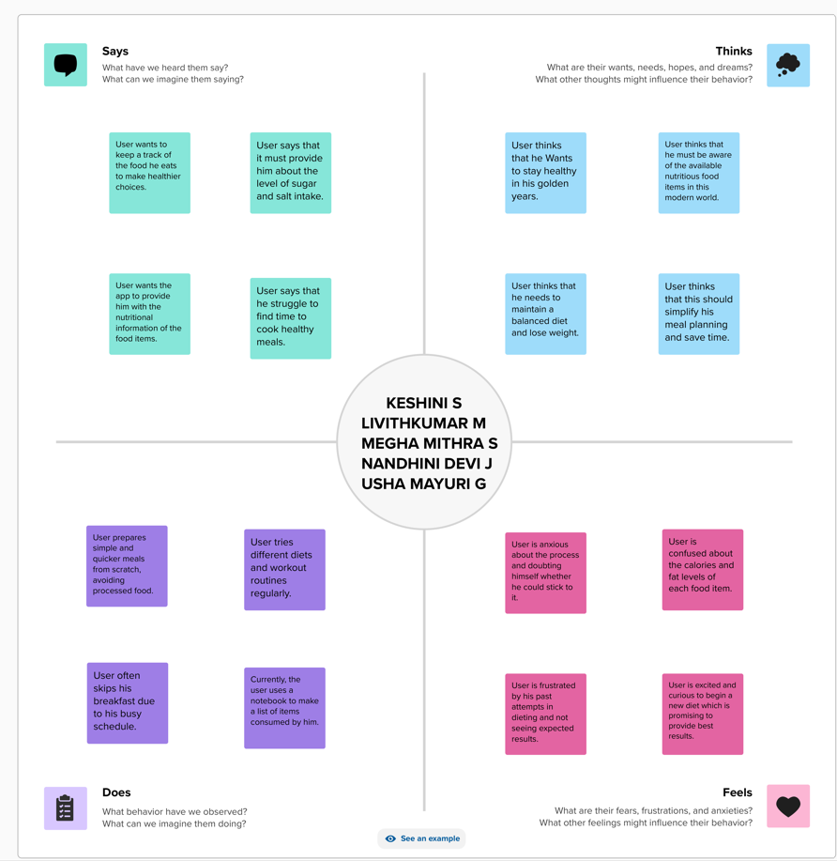

*Figure 1: Empathy Map*

## BRAINSTORMING AND IDEATION

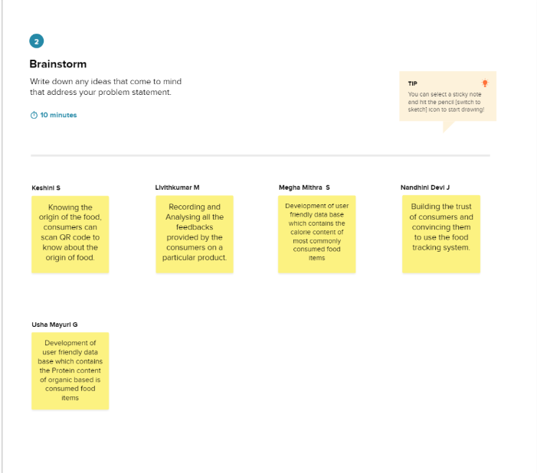

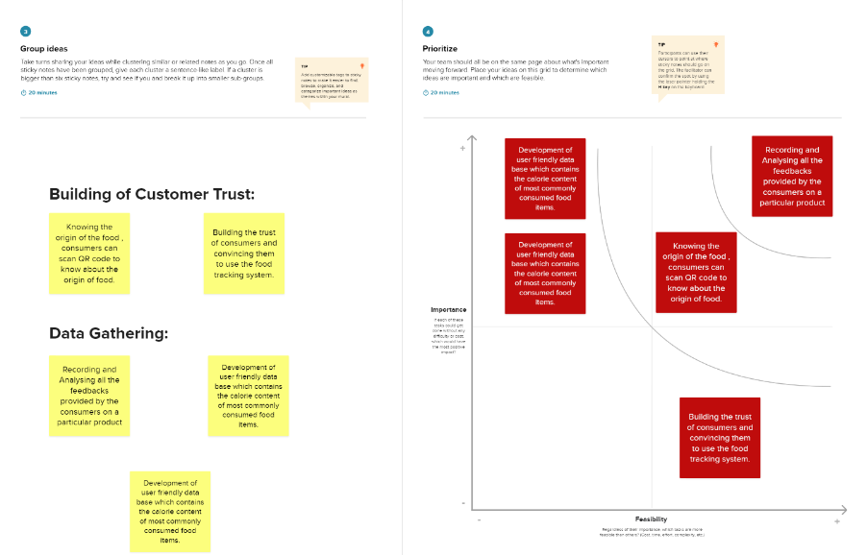

*Figure 2: Brainstorming and Ideation Map*

# PROJECT DESIGN

## SOLUTION ARCHITECTURE

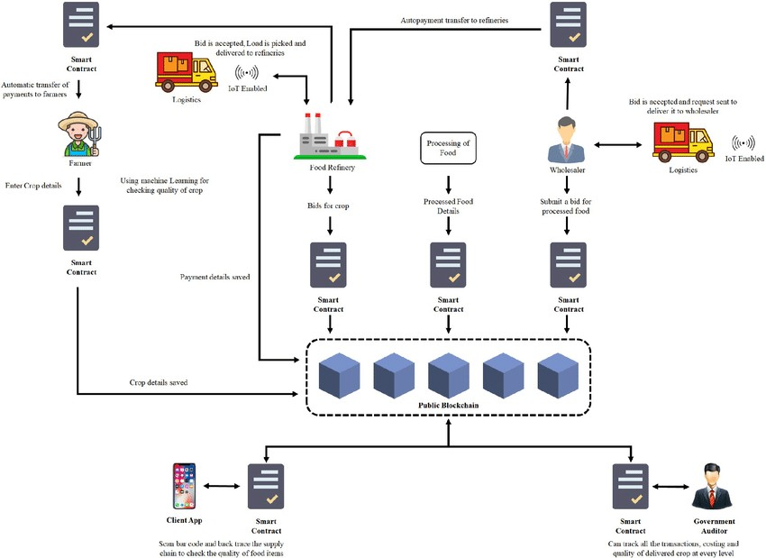

*Figure 3: Solution Architecture for the problem*

## DATA FLOW DIAGRAM

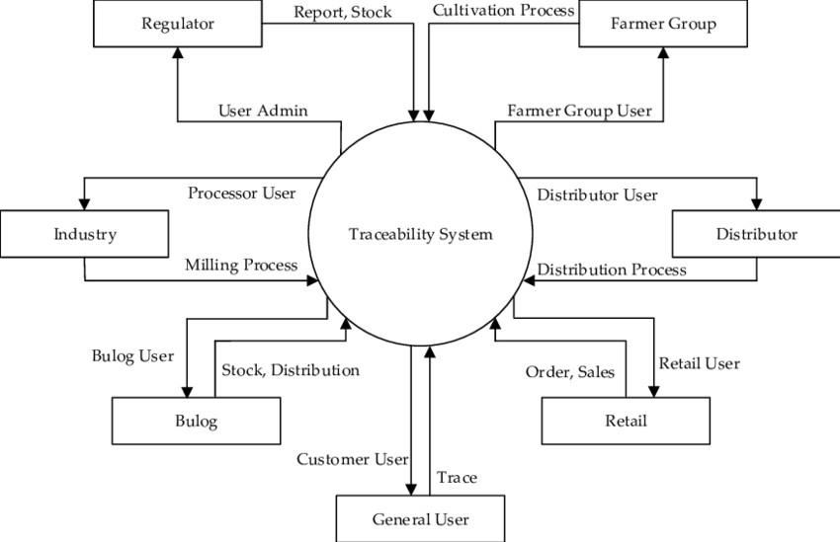

*Figure 4: Data Flow Diagram*

# CODING AND SOLUTIONING

## 

|  |  |  |  |
| --- | --- | --- | --- |
| **S.No.** | **Parameter** | **Values** | **Screenshot** |
| 1. | Information gathering | Setup all the Prerequisite: |  |
| 2. | Extract the zip files | Open to VS code |  |
| 3. | Remix IDE  Platform  exploring | Deploy the smart contract code  Deploy and run the transaction. By selecting the environment - inject the MetaMask. |  |
| 4 | Open file explorer | Open the extracted file and click on the folder  Open src, and search for utiles.  Open cmd enter command   1. npm install 2. npm bootstrap 3. npm start |  |
| 5 | LOCAL HOST IP ADDRESS | Copy the address and open it to chrome so you can see the front end of your project. |  |

# RESULT

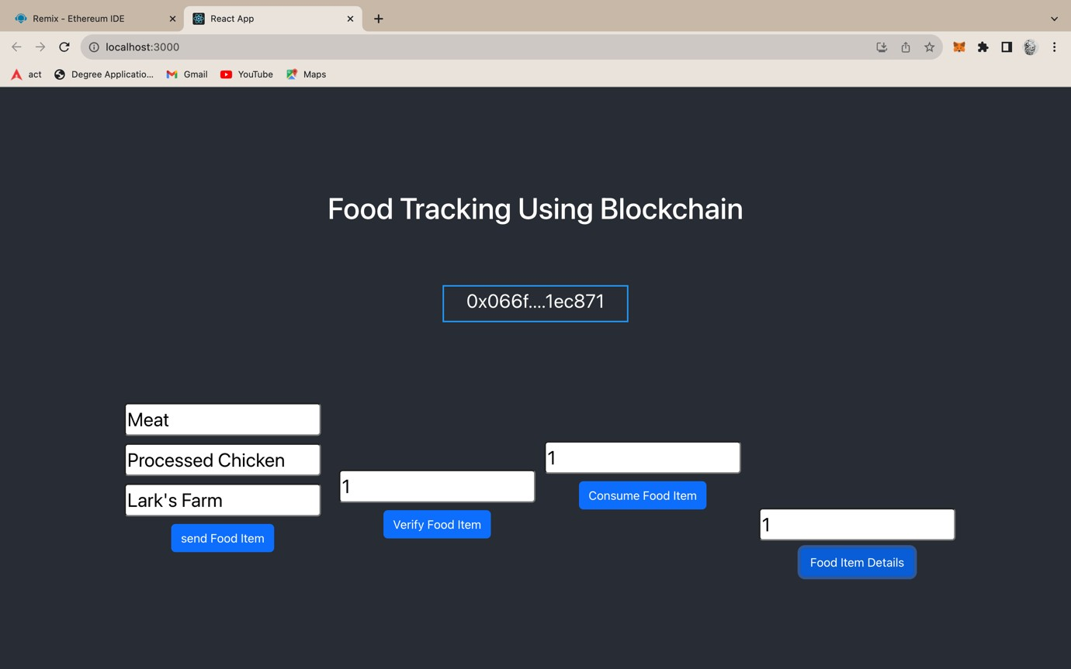

*Figure 9: Project Frontend*

# ADVANTAGES AND DISADVANTAGES

## ADVANTAGES

* + 1. Enhanced Traceability
    2. Improved Transparency
    3. Reduced food frauds
    4. Increased accountability

## DISADVANTAGES

* + 1. Implementation cost
    2. Scalability
    3. Standardisation
    4. User adoption

# CONCLUSION

The Blockchain-Based Food Tracking System is a ground-breaking project that will revolutionize the food industry by providing consumers with unprecedented transparency, traceability, and safety in their food choices. By harnessing blockchain technology, we can ensure that the food we consume is of high quality, ethically sourced, and free from contamination, ultimately fostering trust and accountability throughout the food supply chain.